**TASK 6: Sales Trend Analysis Using Aggregations**

Objective: Analyze monthly revenue and order volume.

Tools: MySQL

Deliverables: SQL script + results table

Hints/Mini Guide:

a.Use EXTRACT(MONTH FROM order_date) for month.

b.GROUP BY year/month.

c.Use SUM() for revenue.

d.COUNT(DISTINCT order_id) for volume.

e.Use ORDER BY for sorting.

f.Limit results for specific time periods.

**a.Use EXTRACT(MONTH FROM order_date) for month.**

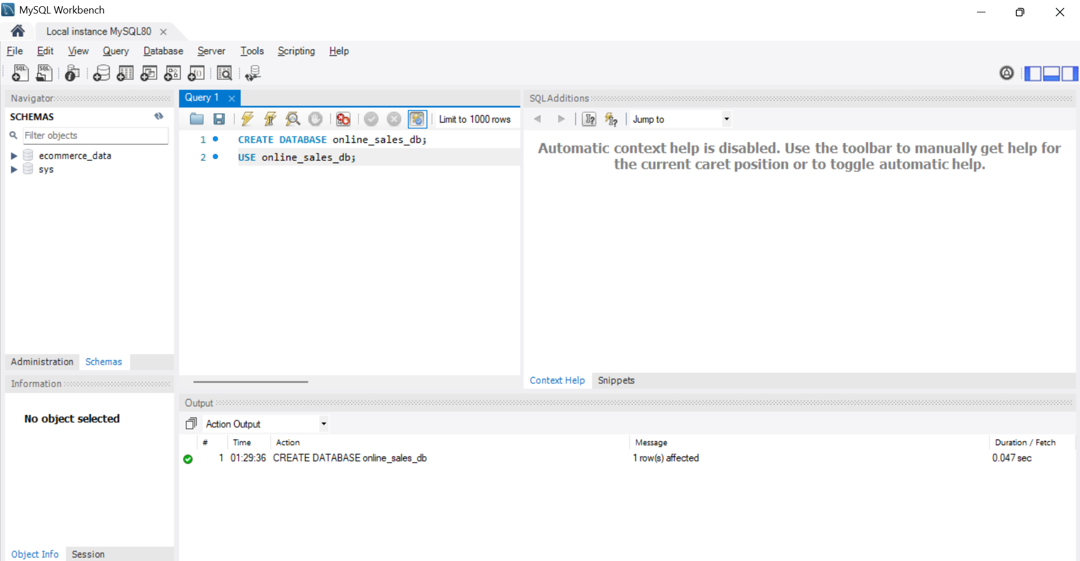

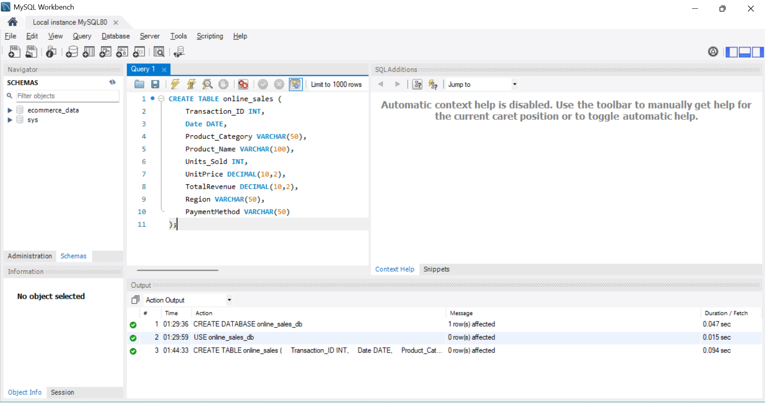

**CREATE TABLE online_sales (**

**Transaction_ID INT,**

**Date DATE,**

**Product_Category VARCHAR(50),**

**Product_Name VARCHAR(100),**

**Units_Sold INT,**

**UnitPrice DECIMAL(10,2),**

**TotalRevenue DECIMAL(10,2),**

**Region VARCHAR(50),**

**PaymentMethod VARCHAR(50)**

**);**

**a.Use EXTRACT(MONTH FROM order_date) for month.**

SELECT COUNT(*) FROM online_sales;

SELECT Date,

EXTRACT(MONTH FROM Date) AS order_month

FROM online_sales;

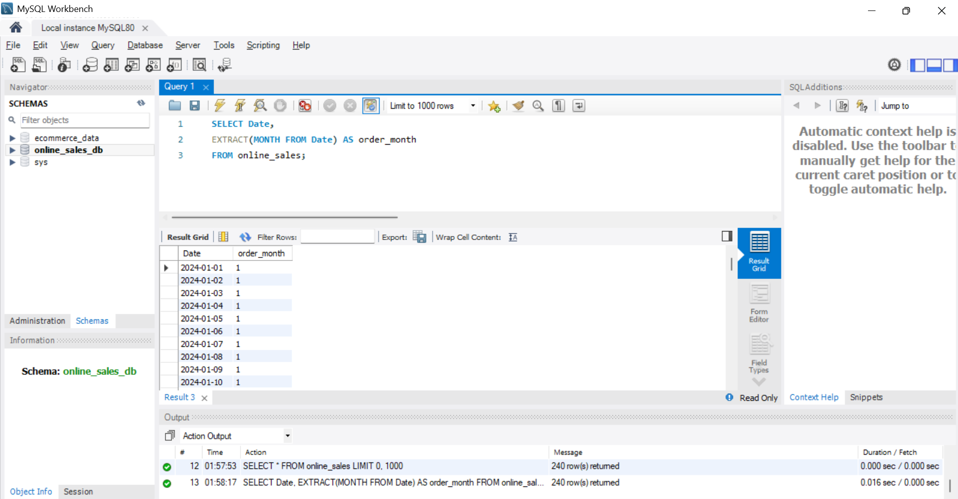

**b. GROUP BY year/month.**

SELECT

EXTRACT(MONTH FROM Date) AS order_month,

COUNT(*) AS total_orders

FROM online_sales

GROUP BY order_month

ORDER BY order_month;

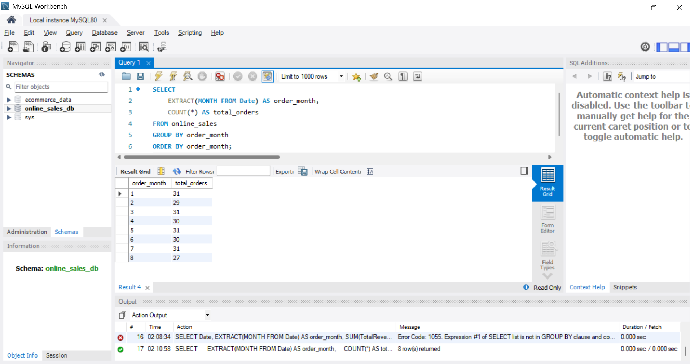

c.Use SUM() for revenue.

**SELECT**

**EXTRACT(MONTH FROM Date) AS order_month,**

**SUM(TotalRevenue) AS monthly_revenue**

**FROM online_sales**

**GROUP BY order_month;**

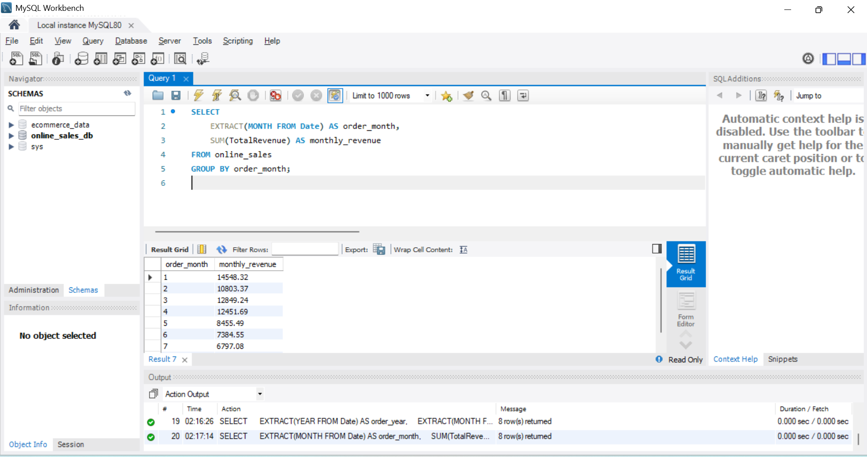

d.COUNT(DISTINCT order_id) for volume.

**SELECT**

**EXTRACT(YEAR FROM Date) AS order_year,**

**EXTRACT(MONTH FROM Date) AS order_month,**

**COUNT(DISTINCT Transaction_ID) AS order_volume**

**FROM online_sales**

**GROUP BY order_year, order_month**

**ORDER BY order_year, order_month;**

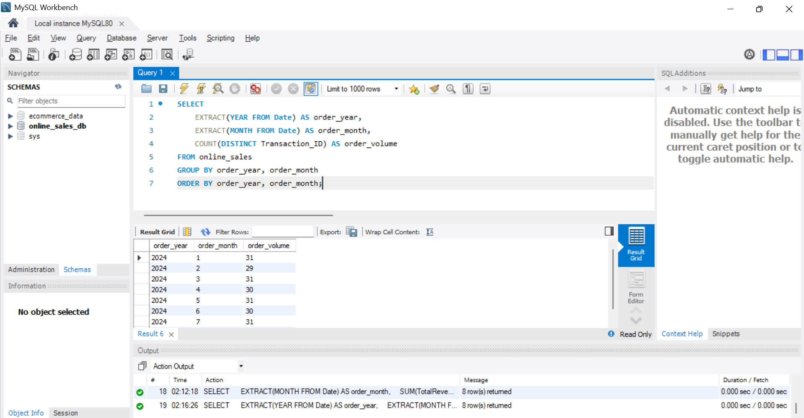

**e.Use ORDER BY for sorting.**

**SELECT**

**EXTRACT(MONTH FROM Date) AS order_month,**

**SUM(TotalRevenue) AS monthly_revenue**

**FROM online_sales**

**GROUP BY order_month**

**ORDER BY order_month;**

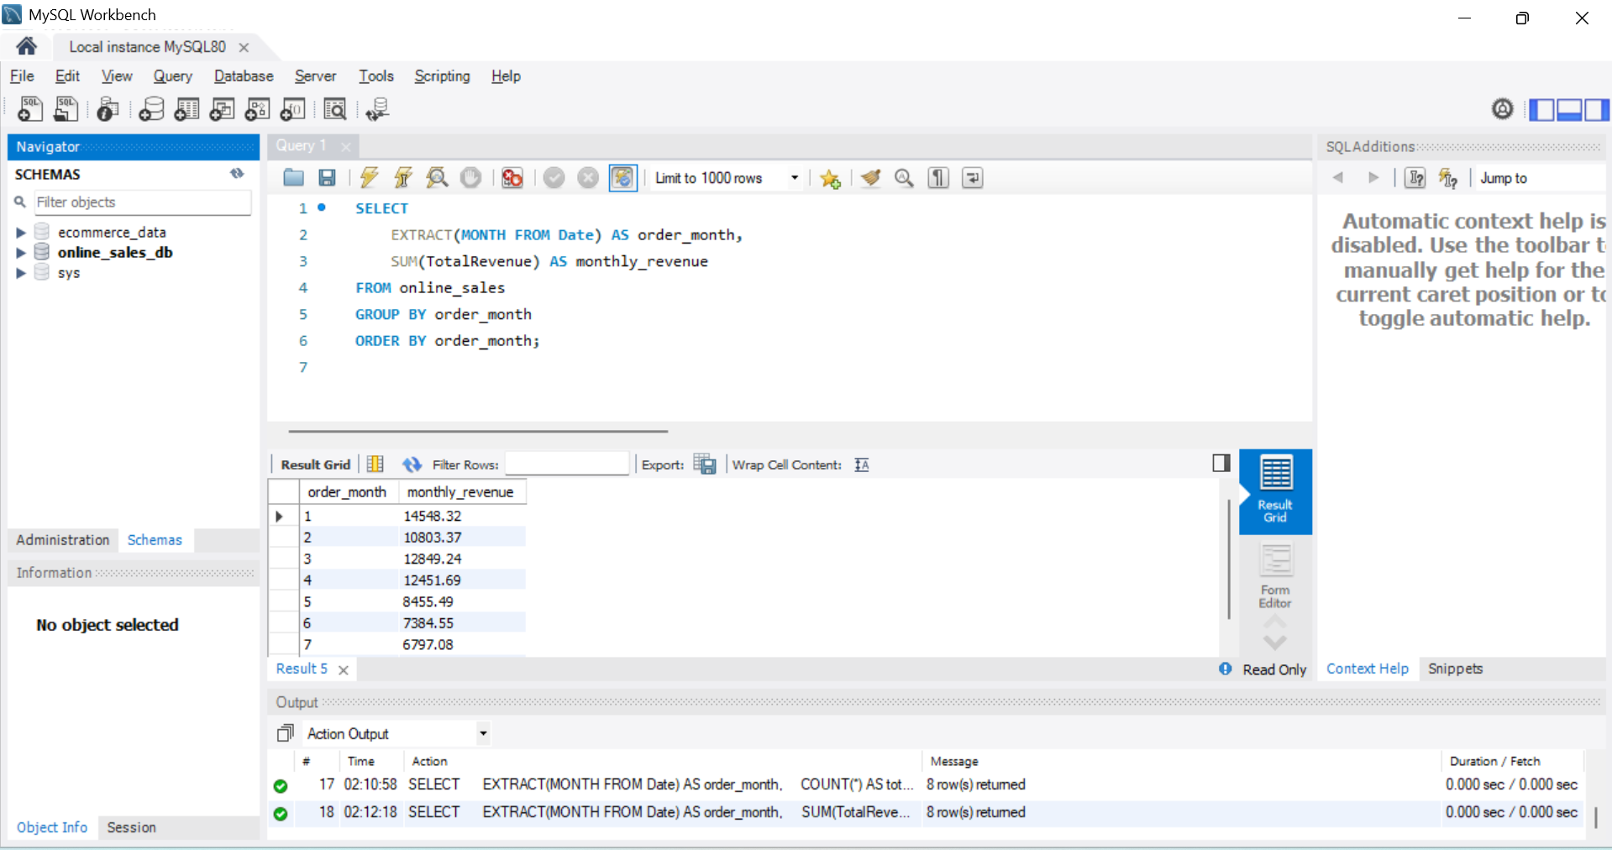

**f.Limit results for specific time periods.**

**SELECT**

**COUNT(DISTINCT Transaction_ID) AS order_volume**

**FROM online_sales**

**WHERE YEAR(Date) = 2023 AND MONTH(Date) = 5;**

